**Term Project [ESC113]**

|  |  |  |
| --- | --- | --- |
| **GROUP 10** **(Contributors)** | | |
| SL NO | NAME | ROLL NO |
| 1 | Pratyush Gupta | 220813 |
| 2 | Priyanshu Maurya | 220827 |
| 3 | Abhilasha | 220033 |
| 4 | Aryan Nigam | 220227 |
| 5 | Ujjwal Bisaria | 221154 |
| 6 | Supriya Sinha | 221107 |
| 7 | Aaditya Amlan Panda | 220007 |
| 8 | Pranshu Kumar | 220799 |
| 9 | Shreyansh Ranjan | 221032 |

**Introduction:** Chemical Reactors play a crucial role in various industries, so it is essential to manage them efficiently. Assessing the level of reactant within a reactor is one of the critical aspects of this efficient management. This helps avoid shortages, optimize production, ensure timely replenishment, and avoid costly disturbances. Developing a mathematical model based on **the Navier-Stokes ODEs** gives a potential approach to this problem. This project aims to explore the formulation and implementation of this mathematical model by considering the assumptions of the incompressibility property of the reactant and utilizing the basics of fluid dynamics principles. This project could enhance operational control and levitate the overall efficiency and productivity of chemical reactions.

**Problem Statement**: "Develop a mathematical model based on the Navier-Stokes ordinary differential equations (ODEs) to deduce the level of reactant left in a chemical reactor, provided the reactant follows the incompressibility property, which can be useful in determining the flow rate and time required in emptying the container or adding more to it.”

A tank contains water at an initial depth yo = 1 m. The tank diameter is D = 250 mm. A hole of diameter d = 2 mm appears at the bottom of the tank. A reasonable model for the water level over time is

dy/dt = - (d/D)2**√**2gy y (0) = yo 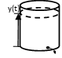

Using 11-point and 21-point Euler methods, estimate the water depth after t = 100 min, and compute the errors compared to the exact solution:

Y exact(t) = [**√**yo - (d/D)2**√**(gt/2)]2

**Approach**: To solve the Navier-Stokes Equation for incompressible fluid flow, we assume that the velocity and pressure of the fluid do not change with time. The general form of the equation can be written as:

ρ(∂v/∂t + v · ∇v) = -∇p + μ∇²v + f

The equation in the illustration above is based on this particular case of the Navier-Stokes Equation (Incompressible fluid flow), where the flow is assumed to be unidirectional and restricted to a single coordinate only, setting specific boundary conditions to eliminate the other coordinates. The resulting ODE can be solved using Euler’s method.

**Euler Methods**: -

yi, yi+1 = value of y in the ith and (i+1)th iteration respectively

h = step size = (xN-xO)/N where xN, xO are values of x at first and last boundary points and N is the total number of points when counted from 0

* Explicit Euler method: yi+1 = yi + hf (xi, yi)
* Implicit Euler Method: yi+1 = yi + hf (xi+1, yi+1): This requires an iterative process to solve since f is calculated in the future. Here Newton’s method has been used to code implicit Euler’s method.

**Newton’s iterative process**: -

When Taylor’s series is evaluated at a root of the function and approximated to the first derivative becomes 0 ≈ f(x(k)) + f’(x(k))(x-x(k)), which is further used to solve for x.

**x = x(k) − f(x(k))/f’(x(k)).** To make this iterative, we calculate x(LHS) at the k+1 iteration.

**Parameters defined in the code: -**

a = 0 [initial time in seconds(the starting point)];

b = 100*60 [final time in seconds(the endpoint)];

N = the number of nodes (points) (In our case, N is taken to be **11 & 21** for demonstration and can be varied to check accuracy and stability. It is decreased to check stability as step size increases).

h = -1*(a-b)/N [step size (time step)];

t = Time;

y = Height of Chemical in Reactor [calculated using **Explicit** and **Implicit** Euler methods]

exact = exact height [calculated from the formula directly]

RE = exact-y/exact [Relative Error in height calculated using Euler method]

d =hole diameter =2/1000;

D =tank diameter =250/1000;

g = 9.8 [acceleration due to gravity];

**Key Plots: -**

1. The first code contains explicit Euler for 11 points (0 to 11). The second code contains implicit Euler for 11 points (0 to 11). The first graph contains the plot of concentration vs time and second graph contains error vs time. The graph plotted in both codes comes out to be same showing that the accuracies of either method are equal.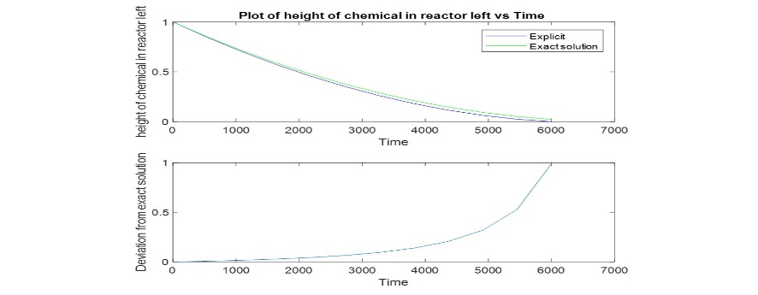
2. The third code contains explicit Euler for 21 points (0 to 21). The fourth code contains an implicit Euler for 21 points (0 to 21). The key difference from the 11-point code is that the deviation from the exact solution has reduced significantly. This shows that **the step size decreases as N increases, and the approximate solutions come closer to the same solutions**.
3. 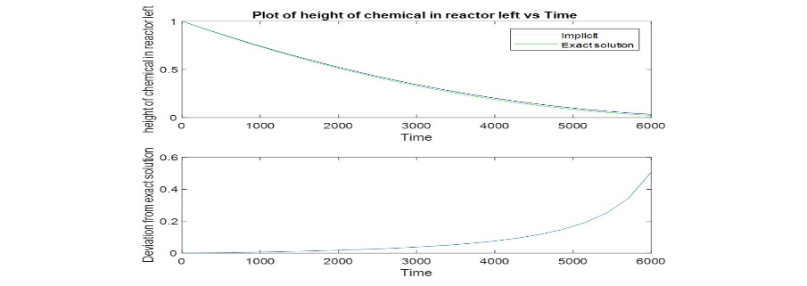
4. The fifth and sixth codes are based on stability checks for explicit and implicit Euler methods. Here we have fixed N=4 since h stability comes between h= (b-a)/4 and (b-a)/5. Here the explicit graph deviates visibly more from the implicit graph, showing that the implicit **Euler is more stable than the explicit Euler**.
5. 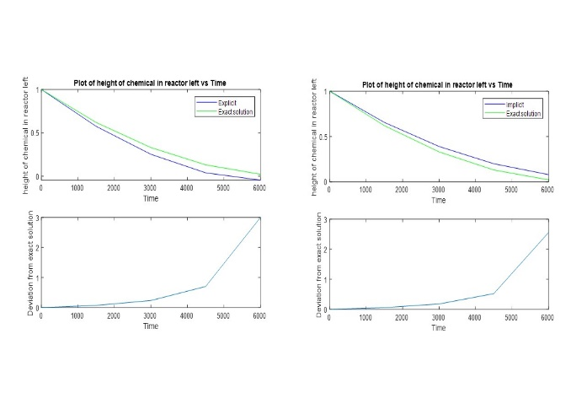

**Conclusion**: -

The final height of the chemical in the reactor is displayed on the screen.

For **11-point** method: -

Implicit Euler, y=0.0441; Explicit Euler, y=0.0002

Exact value:-0.022

For **21-point** method: -

Implicit Euler, y=0.0339; Explicit Euler, y=0.0109

Exact value:-0.022